**Industrial Internship Report on**

**”MOVIE TICKET BOOKING SYSTEM”**

**Prepared by**

**THIRISHA. M**

|  |
| --- |
| *Executive Summary* |
| This report provides details of the Industrial Internship provided by upskill Campus and The IoT Academy in collaboration with Industrial Partner UniConverge Technologies Pvt Ltd (UCT).  This internship was focused on a project/problem statement provided by UCT. We had to finish the project including the report in 6 weeks’ time.  My project was online movie ticket booking system using Java. The project type is a software development project focused on creating a platform for users to browse and purchase Movie tickets online.  This internship gave me a very good opportunity to get exposure to Industrial problems and design/implement solution for that. It was an overall great experience to have this internship. |

DATE OF SUBMISSION : 14/07/2023

DURATION : 1ST JUNE – 14TH JULY

**TABLE OF CONTENTS**

1 Preface 3

2 Introduction 5

2.1 About UniConverge Technologies Pvt Ltd 5

2.2 About upskill Campus 9

2.3 Iot Academy 11

2.4 Objective 11

2.5 Reference 11

3 Problem Statement 12

4 Existing and Proposed solution 13

5 Proposed Design/ Model 14

6 Performance Test 16

6.1 Test Plan/ Test Cases 16

6.2 Performance Outcome 18

7 My learnings 19

8 Future work scope 20

# Preface

This project report serves as the preface to my work on the development of an Movie Ticket Booking System using Java. It provides an introduction to the project, highlighting its significance and purpose, and sets the stage for the subsequent sections of the report.

Throughout my internship, I had the opportunity to explore the intersection of technology and healthcare, recognizing the immense potential for digital solutions to enhance the efficiency and quality of patient care. With this realization, I embarked on the journey of creating an Electronic Healthcare System, leveraging the power of Java programming.

The healthcare industry has been witnessing a paradigm shift towards digitization, driven by the need for improved record-keeping, streamlined administrative processes, and enhanced accessibility to medical information. Recognizing these evolving needs, the objective of this project was to develop a comprehensive system that could effectively address these challenges and facilitate better healthcare management.

In this preface, I would like to express my gratitude to Upskill campus for providing me with this valuable opportunity to work on this project. The support and guidance provided by my supervisors and colleagues have been instrumental in shaping the outcome of this endeavor.

Throughout the project, I have adhered to the principles of software engineering, employing Java as the primary programming language. The system was designed to encompass various modules, including patient registration, appointment scheduling, and medical record management. These modules were carefully crafted to ensure a seamless and intuitive user experience, catering to the specific needs of healthcare professionals.

How Program was planned

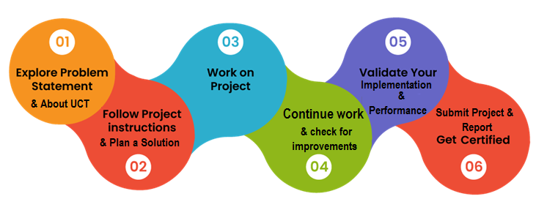

However, it is important to acknowledge the challenges encountered during the development process. Overcoming technical complexities, ensuring data security and privacy, and meeting the diverse requirements of different healthcare facilities were among the obstacles faced. I hope that this project serves as a valuable contribution to the field of healthcare technology and inspires future advancements in the realm of electronic healthcare systems. It is my sincere hope that this project will contribute to the ongoing efforts to improve patient care and revolutionize healthcare management practices.

Once again, I extend my gratitude to everyone who supported me throughout this journey. I am thrilled to present this final report and share the outcomes of my work on the Electronic Healthcare System using Java.

Thank you.

Thirisha.M

# Introduction

## About UniConverge Technologies Pvt Ltd

A company established in 2013 and working in Digital Transformation domain and providing Industrial solutions with prime focus on sustainability and RoI.

For developing its products and solutions it is leveraging various**Cutting Edge Technologies e.g. Internet of Things (IoT), Cyber Security, Cloud computing (AWS, Azure), Machine Learning, Communication Technologies (4G/5G/LoRaWAN), Java Full Stack, Python, Front end**etc.

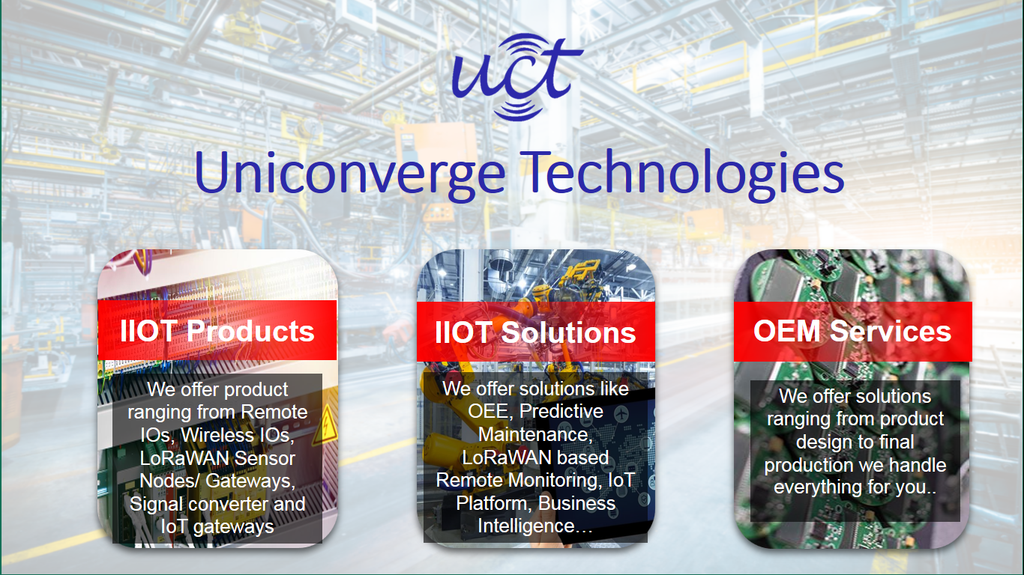

1. UCT IoT Platform **(****)**

**UCT Insight** is an IOT platform designed for quick deployment of IOT applications on the same time providing valuable “insight” for your process/business. It has been built in Java for backend and ReactJS for Front end. It has support for MySQL and various NoSql Databases.

* It enables device connectivity via industry standard IoT protocols - MQTT, CoAP, HTTP, Modbus TCP, OPC UA
* It supports both cloud and on-premises deployments.

It has features to  
• Build Your own dashboard  
• Analytics and Reporting  
• Alert and Notification  
• Integration with third party application(Power BI, SAP, ERP)  
• Rule Engine

 

1. **Smart Factory Platform (****)**

Factory watch is a platform for smart factory needs.

It provides Users/ Factory

* with a scalable solution for their Production and asset monitoring
* OEE and predictive maintenance solution scaling up to digital twin for your assets.
* to unleased the true potential of the data that their machines are generating and helps to identify the KPIs and also improve them.
* A modular architecture that allows users to choose the service that they what to start and then can scale to more complex solutions as per their demands.

Its unique SaaS model helps users to save time, cost and money.

 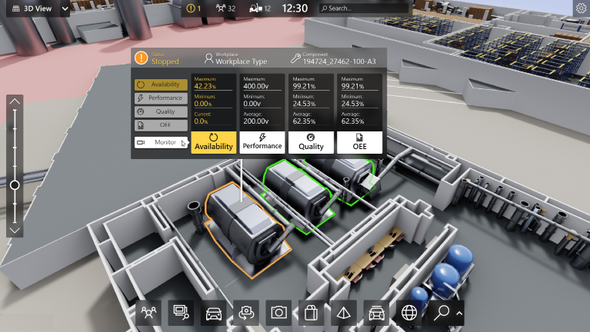

1.  based Solution

UCT is one of the early adopters of LoRAWAN teschnology and providing solution in Agritech, Smart cities, Industrial Monitoring, Smart Street Light, Smart Water/ Gas/ Electricity metering solutions etc.

1. Predictive Maintenance

UCT is providing Industrial Machine health monitoring and Predictive maintenance solution leveraging Embedded system, Industrial IoT and Machine Learning Technologies by finding Remaining useful life time of various Machines used in production process.



## About upskill Campus (USC)

upskill Campus along with The IoT Academy and in association with Uniconverge technologies has facilitated the smooth execution of the complete internship process.

USC is a career development platform that delivers **personalized executive coaching** in a more affordable, scalable and measurable way.



Seeing need of upskilling in self paced manner along-with additional support services e.g. Internship, projects, interaction with Industry experts, Career growth Services

<https://www.upskillcampus.com/>

upSkill Campus aiming to upskill 1 million learners in next 5 year

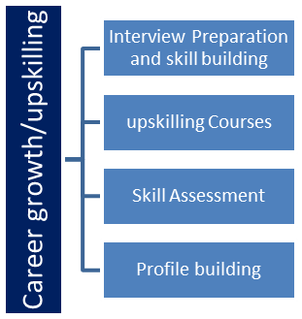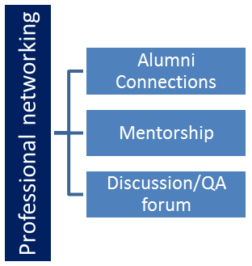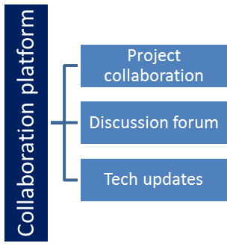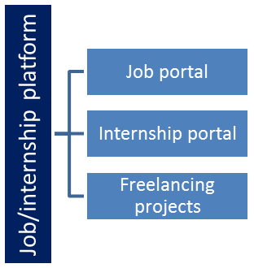

## The IoT Academy

The IoT academy is EdTech Division of UCT that is running long executive certification programs in collaboration with EICT Academy, IITK, IITR and IITG in multiple domains.

## Objectives of this Internship program

The objective for this internship program was to

 ☛ get practical experience of working in the industry.

 ☛ to solve real world problems.

 ☛ to have improved job prospects.

 ☛ to have Improved understanding of our field and its applications.

 ☛ to have Personal growth like better communication and problem solving.

## References:

While I couldn't provide specific papers on the exact problem of "Online Movie Ticket Booking System," here are a few relevant references related to online ticket booking systems and related topics:

1. T. Patel, S. Agrawal, and S. Jaiswal. "Analysis and Design of Online Movie Ticket Booking System." International Journal of Advanced Research in Computer Science and Software Engineering, 2013. (URL: https://www.researchgate.net/publication/259737692_Analysis_and_Design_of_Online_Movie_Ticket_Booking_System)

2. K. Srinivas, S. Priyanka, and A. Trinadh. "A Design of Online Movie Ticket Booking System." International Journal of Advanced Research in Computer Science and Software Engineering, 2015. (URL: https://www.researchgate.net/publication/287170845_A_Design_of_Online_Movie_Ticket_Booking_System)

# Problem Statement

The problem addressed by this project is the inconvenience faced by users in booking movie tickets through traditional methods. Traditional methods often involve long queues, limited availability of seats, and the need to physically visit the theater or booking counters. This results in time wastage and a frustrating user experience.

* **Tentative Approach:**

The tentative approach for implementing the online movie ticket booking system using Java would involve the following steps:

1. Database Design: Create a database to store information about movies, theaters, show timings, seat availability, and user details.

2. User Registration and Authentication: Implement a user registration and authentication system to allow users to create accounts and securely log in to the system.

3. Movie Selection and Show Timings: Display a list of movies currently playing, along with their show timings. Allow users to select a movie and choose a preferred show timing.

4. Seat Selection: Provide a graphical interface for users to view the theater layout and select seats according to their preference. Update seat availability in real-time to prevent double booking.

5. Payment Integration: Integrate a secure payment gateway to facilitate online transactions. Allow users to make payments using credit/debit cards, digital wallets, or other supported payment methods.

# Existing and Proposed solution

**EXISTING SYSTEM**

There are several existing online movie ticket booking systems available that serve as inspiration for this project. Popular platforms such as BookMyShow, Fandango, and Atom Tickets have already implemented online ticket booking systems. These platforms provide various features like seat selection, movie reviews, trailers, and integration with payment gateways.

**PROPOSED SYSTEM**

We derive a taxonomy of intents to capture user information needs in online health forums, and propose novel pattern based features for use with a multiclass support vector machine (SVM) classifier to classify original thread posts according to their underlying intents. Since no dataset existed for this task, we employ three annotators to manually label a dataset of 1,192 Health Boards posts spanning four forum topics.

## Code submission (Github link)

## Report submission (Github link) : first make placeholder, copy the link.

# Proposed Design/ Model

The model for this project would be a software application developed using Java programming language. The application would utilize a database to store movie, theater, and user information. It would provide a user-friendly interface for users to browse movies, select show timings, choose seats, make payments, and receive booking confirmations.

The expected outcome of the project is a functional and user-friendly online movie ticket booking system that streamlines the ticket booking process, eliminates the need for physical visits or long queues, and provides a convenient and secure experience for users. The system should effectively handle user authentication, seat availability, payment processing, and booking management.

Through experiments and user evaluation, the project aims to gather evidence on the usability, performance, and user satisfaction of the system. The feedback and observations from users would guide iterative improvements to enhance the system's functionality and address any identified shortcomings. The ultimate goal is to deliver a robust and reliable online ticket booking system that meets the needs of users and improves their overall movie-going experience.

**Approach:**

The approach to address the problem of online movie ticket booking system using Java would involve the following steps:

1. Requirements Gathering: Understand the specific requirements of the project, including the desired features, user interface, security considerations, and integration with external systems.

2. System Design: Design the overall architecture of the online ticket booking system, including the database schema, user interface design, and system components.

3. Implementation: Develop the software application using Java programming language, following industry best practices and coding standards. Implement the various features such as user registration, movie selection, seat selection, payment integration, and booking confirmation.

4. Testing: Conduct rigorous testing of the system to ensure its functionality, usability, and reliability. Perform unit testing, integration testing, and system testing to identify and fix any issues or bugs.

5. Deployment: Deploy the online ticket booking system on a suitable hosting environment or cloud platform. Configure the necessary infrastructure and ensure scalability and performance.

6. User Evaluation: Gather feedback from users to evaluate the effectiveness and usability of the online ticket booking system. Conduct user surveys, interviews, or usability tests to assess user satisfaction, ease of use, and any areas for improvement.

7. Iterative Improvements: Based on the user feedback and evaluation results, make necessary improvements and enhancements to the system. This may involve refining user interface, optimizing performance, adding new features, or addressing any usability issues.

8. Maintenance and Support: Provide ongoing maintenance and support for the online ticket booking system to ensure its smooth operation. Address any reported issues, apply software updates, and continuously monitor the system's performance.

# Performance Test

The purpose of testing is to discover errors. Testing is the process of trying to discover every conceivable fault or weakness in a work product. It provides a way to check the functionality of components, sub assemblies, assemblies and/or a finished product It is the process of exercising software with the intent of ensuring that the Software system meets its requirements and user expectations and does not fail in an unacceptable manner. There are various types of test. Each test type addresses a specific testing requirement.

The test process is initiated by developing a comprehensive plan to test the general functionality and special features on a variety of platform combinations. Strict quality control procedures are used.

The process verifies that the application meets the requirements specified in the system requirements document and is bug free. The following are the considerations used to develop the framework from developing the testing methodologies.

## Test Plan/ Test Cases

**Unit testing:**

Unit testing involves the design of test cases that validate that the internal program logic is functioning properly, and that program input produce valid outputs. All decision branches and internal code flow should be validated. It is the testing of individual software units of the application .it is done after the completion of an individual unit before integration. This is a structural testing, that relies on knowledge of its construction and is invasive. Unit tests perform basic tests at component level and test a specific business process, application, and/or system configuration. Unit tests ensure that each unique path of a business process performs accurately to the documented specifications and contains clearly defined inputs and expected results.

**Functional test**

Functional tests provide systematic demonstrations that functions tested are available as specified by the business and technical requirements, system documentation, and user manuals.

Functional testing is centered on the following items:

Valid Input : identified classes of valid input must be accepted.

Invalid Input : identified classes of invalid input must be rejected.

Functions : identified functions must be exercised.

Output : identified classes of application outputs must be exercised.

Systems/Procedures : interfacing systems or procedures must be invoked.

**System Test**

System testing ensures that the entire integrated software system meets requirements. It tests a configuration to ensure known and predictable results. An example of system testing is the configuration oriented system integration test. System testing is based on process descriptions and flows, emphasizing pre-driven process links and integration points.

**Performance Test**

The Performance test ensures that the output be produced within the time limits,and the time taken by the system for compiling, giving response to the users and request being send to the system for to retrieve the results.

**Integration Testing**

Software integration testing is the incremental integration testing of two or more integrated software components on a single platform to produce failures caused by interface defects.The task of the integration test is to check that components or software applications, e.g. components in a software system or – one step up – software applications at the company level – interact without error.

**Acceptance Testing**

User Acceptance Testing is a critical phase of any project and requires significant participation by the end user. It also ensures that the system meets the functional requirements.

## Performance Outcome

**Acceptance testing for Data Synchronization:**

The Acknowledgements will be received by the Sender Node after the Packets are received by the Destination Node

The Route add operation is done only when there is a Route request in need

The Status of Nodes information is done automatically in the Cache Updation process

**Build the test plan**

Any project can be divided into units that can be further performed for detailed processing. Then a testing strategy for each of this unit is carried out. Unit testing helps to identity the possible bugs in the individual component, so the component that has bugs can be identified and can be rectified from errors.

# My learnings

**Software:** The chosen software to develop the online movie ticket booking system using Java could include:

1. Java Development Kit (JDK): The JDK provides the necessary tools, libraries, and runtime environment for Java development. It includes the Java programming language, the Java Virtual Machine (JVM), and various development tools.

2. Integrated Development Environment (IDE): An IDE such as Eclipse, IntelliJ IDEA, or NetBeans can be used to write, debug, and test the Java code. These IDEs provide features like code completion, debugging tools, and project management.

3. Java frameworks and libraries: Various Java frameworks and libraries can be utilized to simplify the development process and enhance functionality. For example, the Spring Framework can be used for dependency injection and web application development, while Hibernate can assist with database operations.

The motivation behind this project is to provide a convenient and user-friendly solution for booking movie tickets. Online ticket booking systems offer several advantages, such as the ability to check seat availability in real-time, select preferred seats, and make secure online payments. By automating the ticket booking process, users can save time and have a seamless experience.

# Future work scope

We are currently unable to extract all intents for posts with Combo intent and further work is required to identify all of the intents in a multi-intent forum post. We need to work on expanding our pattern feature set in order to improve classification performance. We would ideally want a larger annotated dataset for more accurate evaluation and a set of annotated forum posts from Med Help to obtain further validation that our classifiers do in fact generalize well to posts from other data sources.